Record No: 0681
BRIGADIER ERNEST FREDERICK JOHN HILL (John)

Elder son of Ernest George Hill

Birth: 6 Aug 1879
Marriage: 26 Sep 1929, at Nun’s Cross Church, Killiskey, Ashford, Co Wicklow to Edeline
Botelier MarjorieBellingham Somerville, youngest dau of Bellingham Arthur
Somerville and Margaret Hall (Nee Clinch)
Death: 19 Nov 1962 Bd Putney Vale Cemetery, London SW

No issue

Source: Somerville Index

Further research:

HILL, Brig. Ernest Frederick John
DSO 1919; MC
Born 6 Aug. 1879; e s of late Ernest George Hill; m 1929, Edeline Botelier Marjorie Bellingham, y d of late Bellingham Arthur Somerville; died 19 Nov. 1962

Education
St Paul’s School; RMA, Woolwich

Career
Entered army, Royal Engineers, 1898; KGO Bengal Sappers and Miners, India, 1901–26; served Waziristan, 1901–02 (medal and clasp); Tibet, 1903–04 (medal); European War, 1914–18, France and Flanders, Mesopotamia and Palestine; CRE 7th Indian Division, 1917–19 (despatches six times, Bt Lieut-Colonel, DSO, MC, 1914 Star and clasp, War medal, Victory medal); Order of Nile, 4th Class; Commandant, KGO Bengal Sappers and Miners, 1922–26; Bt Colonel, 1926; Brigadier, Royal Engineers, General Staff, Army Headquarters, India, 1927–31; retired 1933; Home Office and Ministry of Home Security, 1937–49

Recreations
Polo, shooting

Clubs
United Service, MCC

Address
c/o Lloyds Bank Ltd, 6 Pall Mall, SW1
‘HILL, Brig. Ernest Frederick John’, Who Was Who, A & C Black, 1920–2008; online edn, Oxford University Press, Dec 2007 [http://www.ukwhoswho.com/view/article/oupww/whowaswho/U54756, accessed 28 July 2011
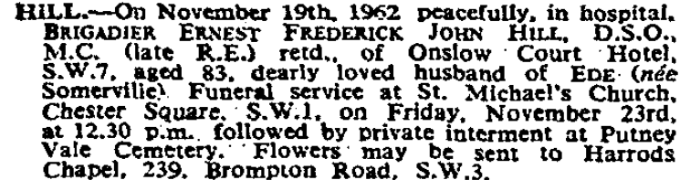
The Times, Wed 21 Nov 1962 & Thu 22 Nov 1962.

John had a distinguished army career. Nonetheless, he was a quiet, unassuming man. He was a great support to Tetty, generally in difficult circumstances and with considerable tact.

He entered the Army at a time when spectacles were not permitted so he wore an eye piece throughout his life. He was, however, a good shot, but, judging by the condition of his gun, which Tetty gave to WBRBS after his death, he shot infrequently.

WBRBS from personal knowledge.

